Jesse Stavro's Doorway
Marshal Tenner Winter

Walkthrough

Chapter 1

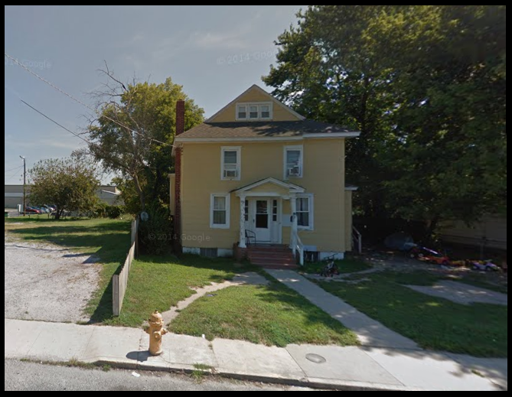

Optional but recommended for first time play:
-open satchel
-take journal
-read journal
-consult journal about doors (then Keys, then Warpers, then Factions)
-other things in the journal include Stillwater, Flower of Life.

Infiltrating the house:
From Under The Overpass:
-east
-north
-north
-northeast (to get to Backyard)
-take box
-south (taking the keychain is optional but the house key on it will unlock front and side door if desired.)
-south (to get to Kitchen)

Getting past the pitbull:
Somewhere on the first floor wanders Gunny the dog. His movements are random. As soon as you are in the same location as Gunny: "Put box on dog". Now Gunny will wander, confused and blind.

First Floor:
From Kitchen:
-east
-north
-examine drawings
-south
-south
-west
-west
-up
-up

Second Floor:
From Top of Stairs:
-east
-north
-take pot
-south
-east
-northeast
-examine trunk
-examine belongings
-talk to woman
-ask about Woman, Jesse, Joe, and Flower
-ask about Sealing the Portal
-southwest
-east
-turn off aquarium, lamp, and projector
-talk to man
-ask about Jesse, Flower, Lydia, and Joe.
-ask about Zach and Attic Key
-follow Riley west
-follow Riley up
-follow Riley up

Attic Lair:
-examine closet
-ask Riley about The Year 1977.

Chapter 2

From Filthy Rest Room:
-north
-talk to Sep
-ask him about Sep, Gwendy, Melvin, Thermostat
-talk to Gwendy
-ask her about Gwendy, Sep, and Melvin
-talk to Melvin
-ask him about Melvin, Sep, and Gwendy
-open toolbox
-take crowbar and flashlight
-break boarded door with crowbar
-southwest
-light flashlight
-north
-press button
-open engine
-take thermostat
-south
-northeast
-give thermostat to Sep
-talk to Riley
-ask Riley about Next Portal
-wait two turns

Chapter 3

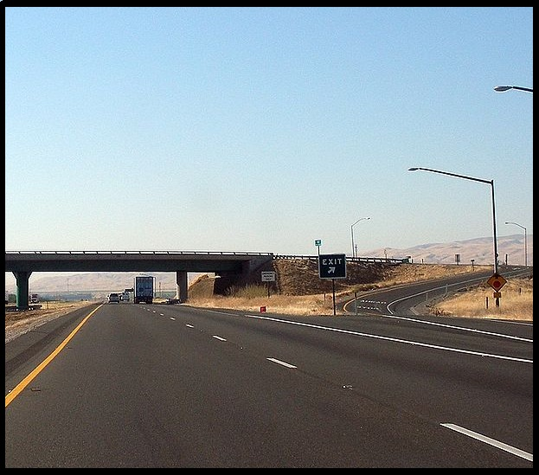

From Dark Road:
-west
-northwest
-open satchel
-put all in satchel
-north
-take all
-north
-northeast
-open cap
-syphon Gremlin
-west
-southwest
-wait one turn
-southeast
-south
-southeast
-east

Chapter 4

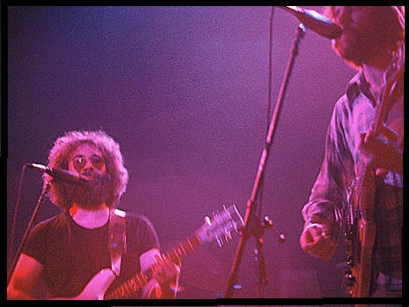

From Inside the VW Bus:
-exit
-talk to deadheads
-ask hippy about Jesse
-east
-enter drum circle
-talk to dancers
-ask Adriana about Jesse
-south
-examine vendors
-examine grill
-talk to woman
-ask her about Jesse
-west
-ask Zach about concert ticket
-find ticket
-type yes
-show nugget of pot to hippy (if you failed to get the nugget of pot, see below)*
-south
-east
-show ticket to bouncer
-south
-south
-south
-south
-north
-north
-ask Haker about Next Portal

*If you failed to get the nugget of pot, you can sneak into the venue. Look for the dumpster, climb on it and climb through the window.

Defeating Haker Ix
Your best chance to hit is by using the crowbar or the hammer to hit him. Otherwise you can "attack Haker". You need to hit him twice. You can only take one hit. A second hit on you from Haker will end your game.

After his defeat, just "take earring".

Chapter 5

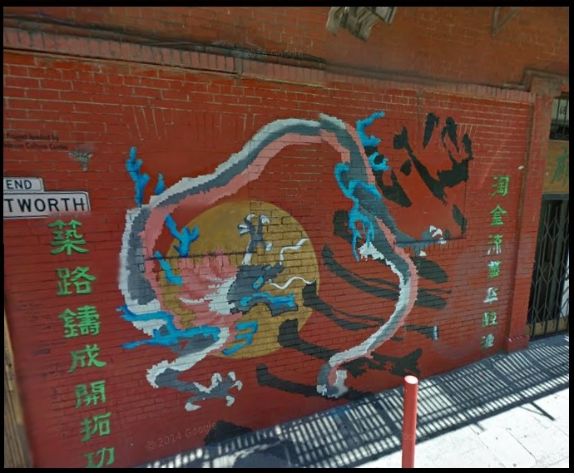

From Washington Street:
-north
-west
-north
-north
-turn machine on
-north
-northwest
-enter pool
-southeast
-open box
-pull green
-confirm
-northwest
-east
-east
-enter door

Epilogue

-examine door
-give earring to Lydia

